Lab # 03
Task 1:
#include<iostream>
using namespace std;
int main()
{
string input;
cout<<"Enter sentence: ";
getline(cin, input);
string token = "";
for(int i=0; i<input.length(); i++)
{
if(input[i]!=' '){
token+=input[i];
}
else{
cout<<"Token: "<<token<<endl;
token="";
}
}
cout<<"Token: "<<token<<endl;
}
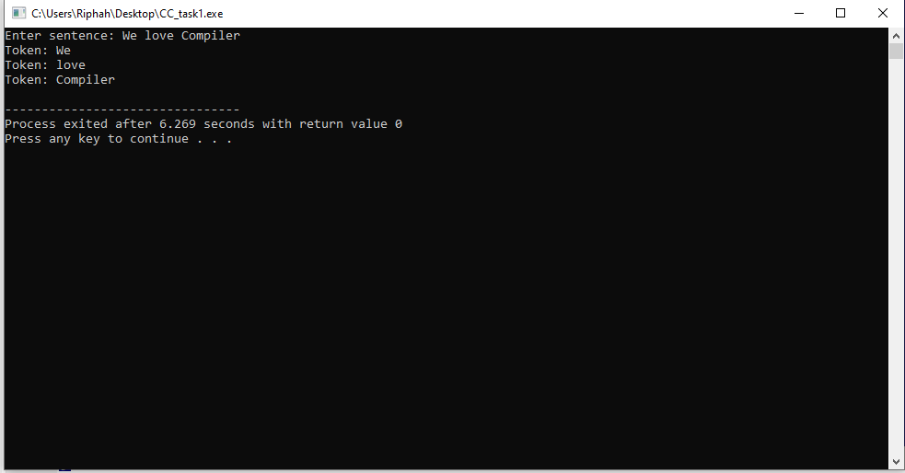

Task 2:
#include<iostream>
using namespace std;
int main()
{
string input;
cout<<"Enter sentence: ";
getline(cin, input);
string token = "";
for(int i=0; i<input.length(); i++)
{
if(input[i]!=' '){
token+=input[i];
}
else{
if(token == "int" || token == "float" || token == "string" || token == "double" || token == "char")
cout<<token<<": KEYWORD\n";
else if(token == "+" || token == "-" || token == "*" || token == "/" || token == "=")
cout<<token<<": OPERATOR\n";
else if(token[0] >='0' && token[0] <='9')
cout<<token<<": NUMBER\n";
else if(token[0] == ';' || token[0] == ')' || token[0] == '(')
cout<<token<<": TERMINATOR\n";
else
cout<<token<<": IDENTIFIER\n";
token="";
}
}
if(token == "int" || token == "float" || token == "string" || token == "double" || token == "char")
cout<<token<<": KEYWORD\n";
else if(token == "+" || token == "-" || token == "*" || token == "/" || token == "=")
cout<<token<<": OPERATOR\n";
else if(token[0] >='0' && token[0] <='9')
cout<<token<<": NUMBER\n";
else if(token[0] == ';' || token[0] == ')' || token[0] == '(')
cout<<token<<": TERMINATOR\n";
else
cout<<token<<": IDENTIFIER\n";
}

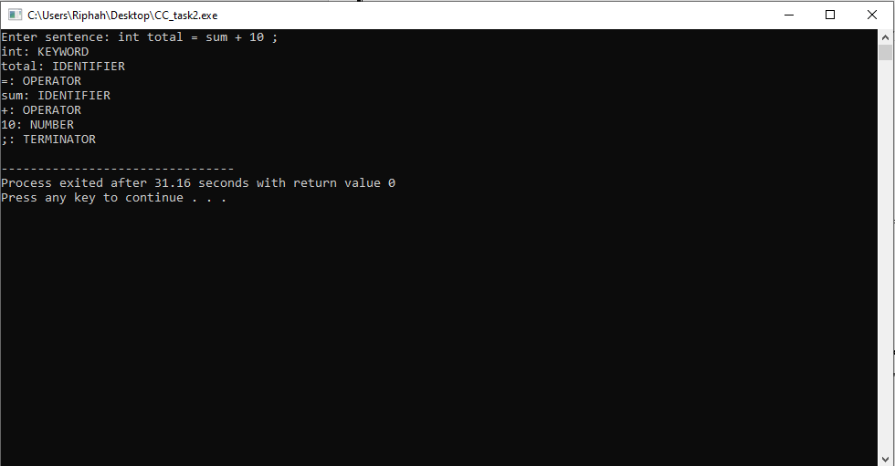

Task 3:
#include<iostream>
using namespace std;
int main()
{
string input;
cout<<"Enter sentence: ";
getline(cin, input);
string token = "";
for(int i=0; i<input.length(); i++)
{
if(input[i]!=' '){
token+=input[i];
}
else{
if(token == "int" || token == "float" || token == "string" || token == "double" || token == "char")
cout<<token<<": KEYWORD\n";
else if(token == "+" || token == "-" || token == "*" || token == "/" || token == "=")
cout<<token<<": OPERATOR\n";
else if(token[0] >='0' && token[0] <='9')
cout<<token<<": NUMBER\n";
else if(token[0] == ';' || token[0] == ')' || token[0] == '(')
cout<<token<<": TERMINATOR\n";
else if(token == "if" || token == "else" || token == "elseif")
cout<<token<<": Conditional Statement\n";
else if(token == "for" || token == "while" || token == "do")
cout<<token<<": Loop Statement\n";
else
cout<<token<<": IDENTIFIER\n";
token="";
}
}
if(token == "int" || token == "float" || token == "string" || token == "double" || token == "char")
cout<<token<<": KEYWORD\n";
else if(token == "+" || token == "-" || token == "*" || token == "/" || token == "=")
cout<<token<<": OPERATOR\n";
else if(token[0] >='0' && token[0] <='9')
cout<<token<<": NUMBER\n";
else if(token[0] == ';' || token[0] == ')' || token[0] == '(')
cout<<token<<": TERMINATOR\n";
else if(token == "if" || token == "else" || token == "elseif")
cout<<token<<": Conditional Statement\n";
else if(token == "for" || token == "while" || token == "do")
cout<<token<<": Loop Statement\n";
else
cout<<token<<": IDENTIFIER\n";
}
